CS4402 Discussion assignment 6

**Question 1**

Generics in programming are a way to create classes, interfaces, and methods that operate on specified types without actually knowing what those types will be at compile time. They allow you to write more flexible and reusable code by making it possible to work with different data types while maintaining type safety

(Lesson: Generics (Updated) (The JavaTM Tutorials > Learning the Java Language), n.d.).

Here's why generics are important in OOP:

1. Type Safety: Without generics, you'd often have to use Object as a type for everything, which can lead to runtime errors when you try to use the data inappropriately. Generics allow you to catch type mismatches at compile time.
2. Code Reusability: With generics, you can write classes and methods that work with a wide range of data types. This promotes code reusability, reducing duplication and making your codebase more maintainable.
3. Readability: Generics make your code more readable because you can express the intention clearly. For example, a List<String> tells you that it's a list of strings.

Below is a Java code snippet to illustrate the concept of generics. In this example, we'll create a generic class called Box that can store any type of object. Here's the code:

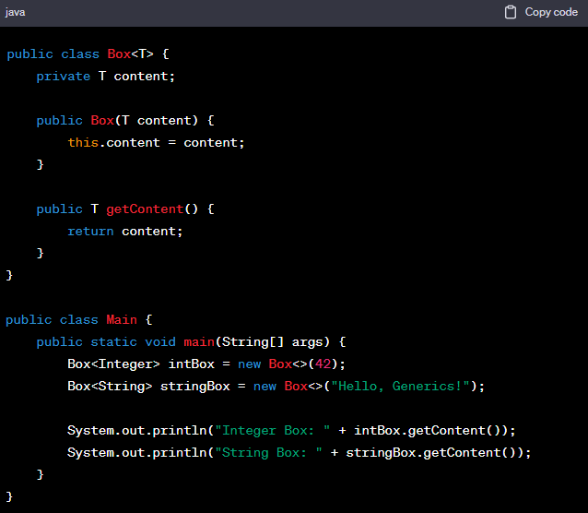

The Box<T> is a class generic definition. It can be constructed by generic content that can be either integer or String.

The generic value is then passed into the object during initialization. Using this mechanism largely boosts the code reusability.

**Question 2**

Open recursion in programming is a concept related to object-oriented programming (OOP) that involves methods in a class calling other methods on the same class. This can be important in OOP for a variety of reasons, such as code organization and promoting a clear, self-contained structure within a class(Hinze, 2007).

The key idea is that a method can delegate some of its work to other methods within the same class, allowing you to break down complex tasks into smaller, more manageable pieces. This promotes code reusability, readability, and maintainability.

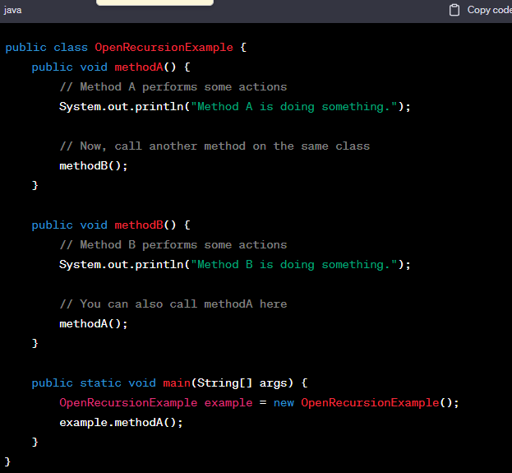

In this code, methodA and methodB are open recursive because they call each other. When you call methodA, it performs some actions and then calls methodB. In turn, methodB does its work and calls methodA. This back-and-forth calling pattern is what makes it open recursion.

Open recursion can help create more modular and maintainable code, as different methods within a class can be designed to handle specific responsibilities, making the codebase easier to understand and extend. It's particularly valuable in larger, more complex object-oriented systems.

**Reference**

Hinze, R. (2007). *Closed and Open Recursion*. http://www.informatik.uni-bonn.de/~ralf

*Lesson: Generics (Updated) (The JavaTM Tutorials > Learning the Java Language)*. (n.d.). Retrieved October 15, 2023, from https://docs.oracle.com/javase/tutorial/java/generics/index.html